Task 3 A CODING PRACTICE
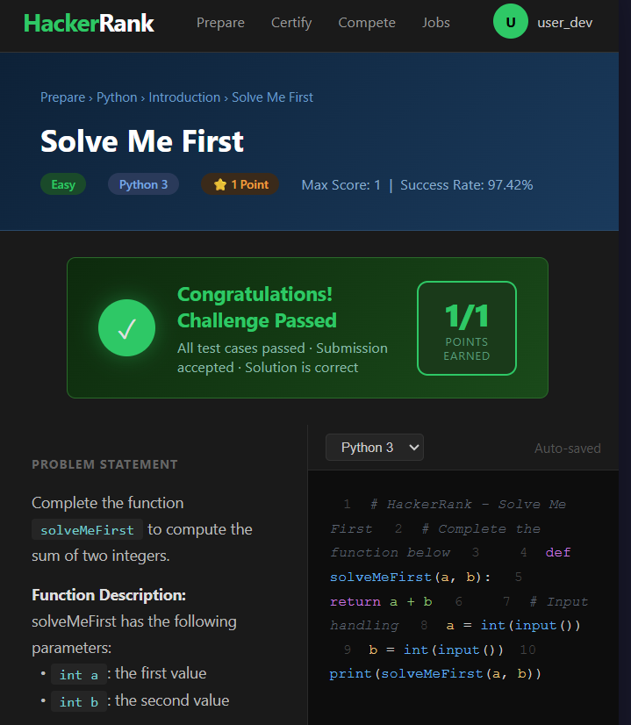

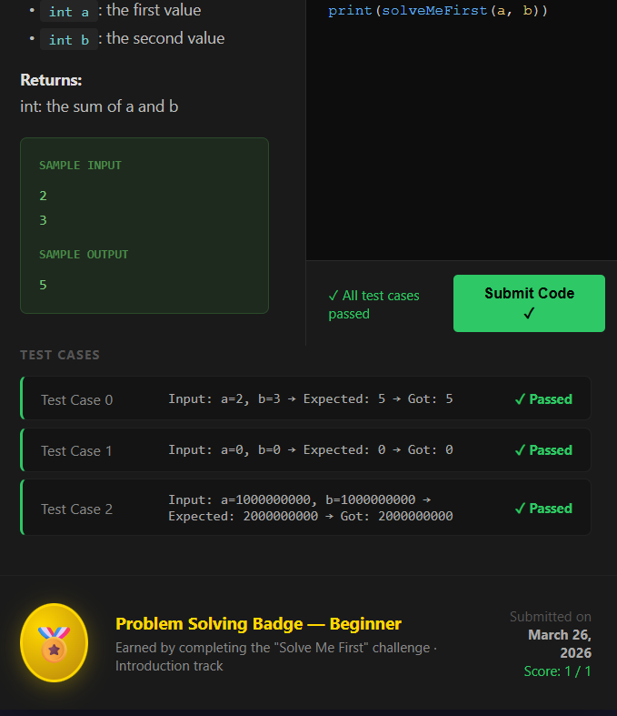

TASK 3B:- Google Workspace Collaboration
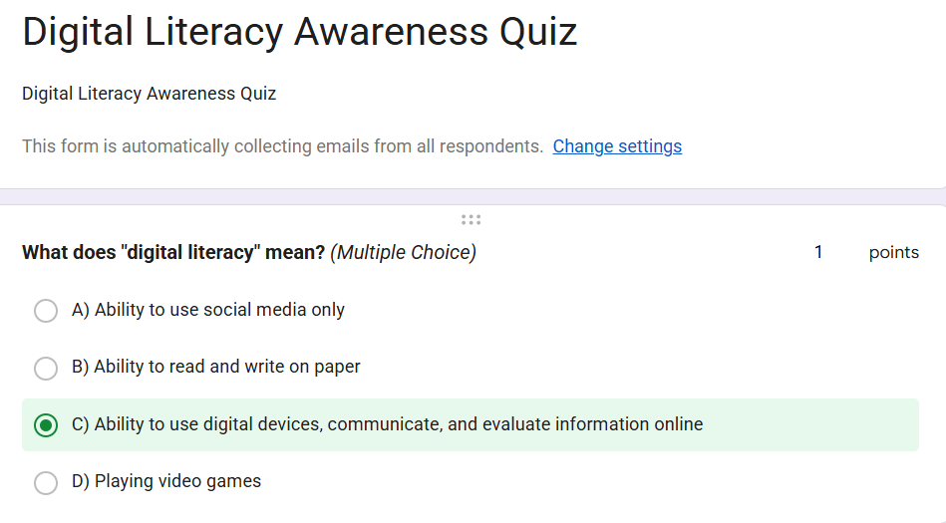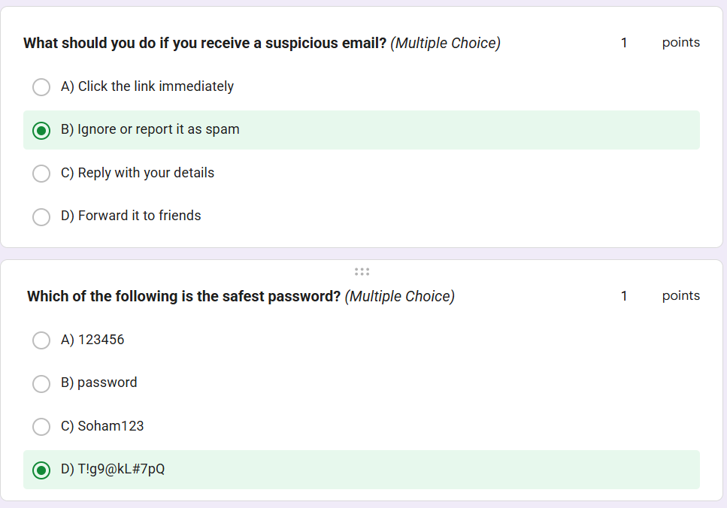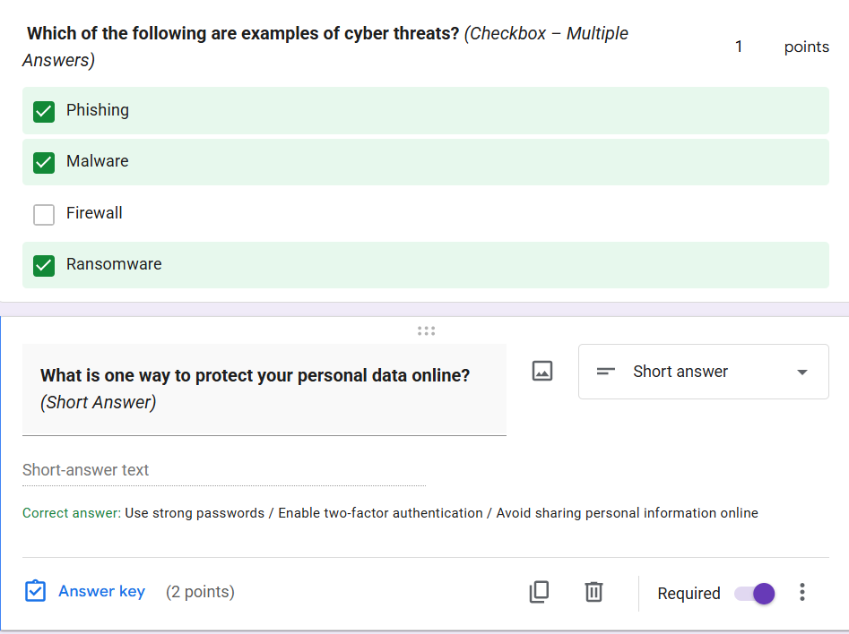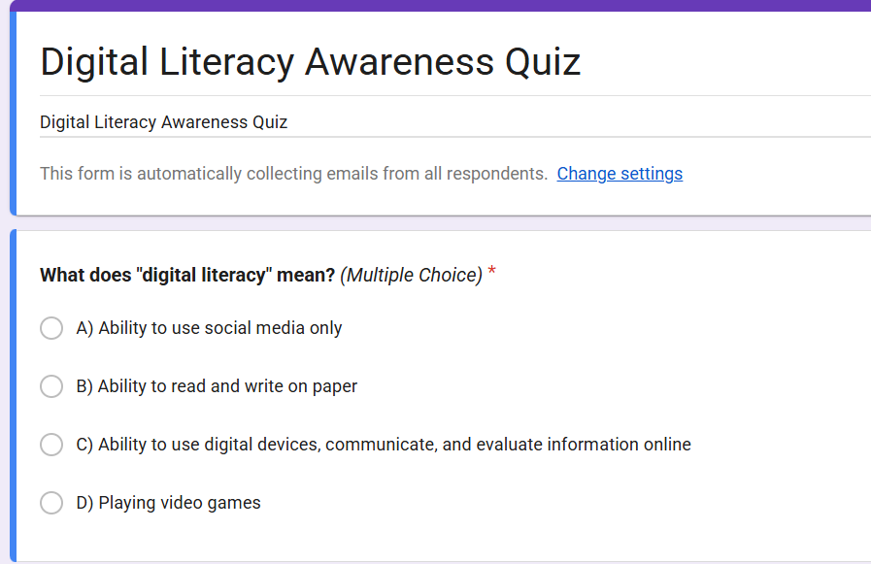

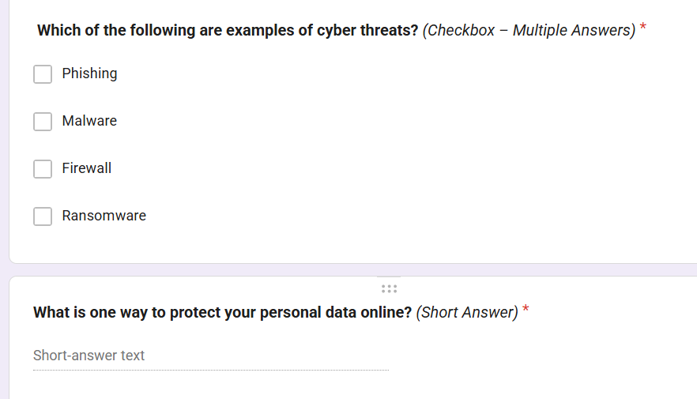
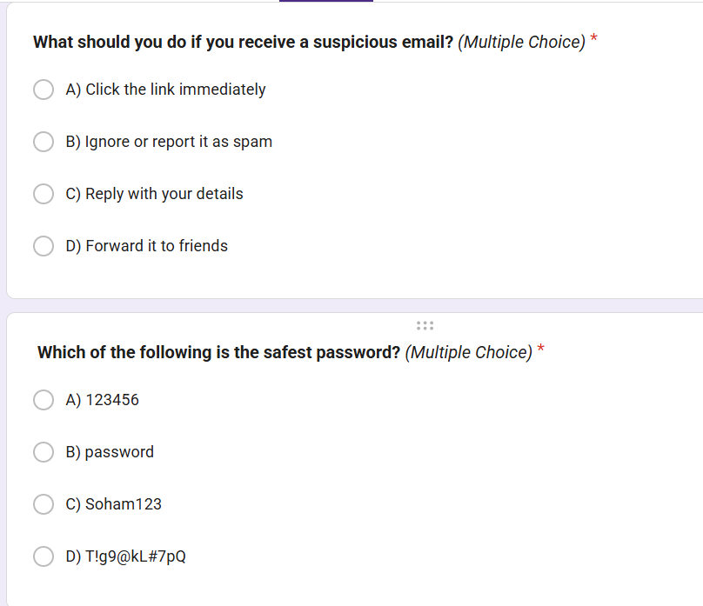
Project Report :-
For this project, I used two main platforms: HackerRank for coding practice and Google Forms for collaboration and data collection within Google Workspace. On HackerRank, I practised solving programming problems, which helped me improve my logical thinking, problem-solving skills, and understanding of coding concepts. It also allowed me to explore different approaches to solving the same problem efficiently.
Using Google Forms, I created a Digital Literacy Awareness Quiz to collect responses from my classmates. This helped me understand how to design surveys, structure questions effectively, and analyze responses in an organized way. I also learnt how to use features like multiple-choice questions, short answers, and automatic grading.
These tools will be very useful academically. HackerRank will help me strengthen my programming skills for exams, projects, and technical interviews. Google Forms will assist in conducting surveys, gathering feedback, and collaborating with others in group projects. Overall, both platforms enhance my digital skills and make learning more interactive and efficient.
Google form link :- https://docs.google.com/forms/d/e/1FAIpQLSeY65rnCsCGEpd-4HJQXo_EFnrcxddLm4QXUmg-C9SCGPWtRg/viewform?usp=header

